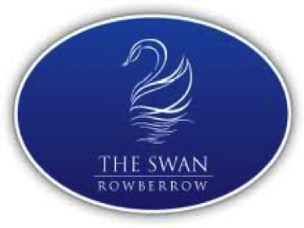
DIAMOND JUBILEE MENU
Starters
Steamed asparagus, soft-boiled egg and hollandaise sauce

Grilled Portobello mushrooms topped with Welsh rarebit

Glazed seared scallops, pea shoots and cauliflower puree

Main course
Prime pork and Butcombe sausages, red cabbage bubble and squeak, garden peas and red wine gravy

Coronation chicken with apricots, flaked almonds, braised rice, watercress and pea shoots

Scotch Sirloin steak, marinated in thyme with buttered jersey royals, watercress and horseradish sauce

Desserts
Queen of puddings- baked egg custard, breadcrumbs and jam topped with meringue

Cranachan-Toasted oatmeal soaked over night in whisky with whipped cream, fresh raspberries and honey

British cheese plate (£2 sup)- Cornish yarg, stinking bishop, Somerset Brie, Mature cheddar, IPA pickle and biscuits

3 courses £22.95 2 courses £18.95

