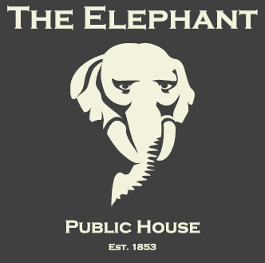

Valentine’s Day Menu

A 7-Course Degustation Menu & a Glass of
Pongracz Sparkling Rosé
£29.95 per person

Purple Sprouting Broccoli & Cambozola Bonbons with a Saffron Hollandaise

♥♥♥♥♥♥

Seared Sashimi Tuna “Nicoise”, with a Green Bean, New Potato & Red Onion Salad, Olive & Anchovy Tapenade, Fresh Tomato Dressing & Fish Roe

♥♥♥♥♥♥

Breaded Monkfish with a Fragrant Thai Mayonnaise

♥♥♥♥♥♥

Giant King Prawns with Passion Fruit Sweet & Sour Sauce

♥♥♥♥♥♥

Fillet Steak, Oyster Mushrooms & Beef Tomato Salsa
with an Oyster Sauce Jus & Chunky Chips

♥♥♥♥♥♥

Strawberries & Cream Cake with a Snood Murdekin Shot

♥♥♥♥♥♥

Beetroot & Orange Jellies

♥ Bookings Essential ♥

20 St. Nicholas Street, Bristol, BS1 1UB
bookings@TheElephantBristol.co.uk
0117 929 3561
www.TheElephantBristol.co.uk

