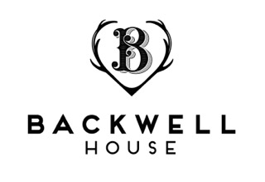
……………………………………………………..

Brixham Crab, broccoli & apple

A salad of spring herbs and vegetables with slow cooked duck egg (v)

Ham hock, cauliflower, mustard & parsley

…………………………………………………………

Monkfish, South Indian spices, asparagus & jersey royals

Sirloin of Hereford cross, wild garlic, caramelised onion & celeriac

Pressed lamb shoulder, anchovies, Jerusalem artichoke & seasonal greens

Potato gnocchi, leeks, walnut & watercress (v)

…………………………………………………………..

Chocolate, orange & honeycombe

Baileys set cream, raspberries & meringue

Selection of local cheese, Backwell chutney & crackers

2 courses £24.50 // 3 courses £30

